HIV Awareness Programme Training for Youth Leaders

Irish Red Cross Youth have developed the Irish Red Cross’ first HIV Awareness Programme, which aims to reach approximately 50% of Irish Red Cross Youth members in 2012 with information on HIV and its prevention as well as fighting stigma towards people living with HIV.  The programme was declared to be the winner of 2011’s International Federation Youth Award in the category of “Healthy youth make a healthy world”. The programme will raise awareness of HIV and AIDS related issues, focusing on preventing new infection and ending stigma. | 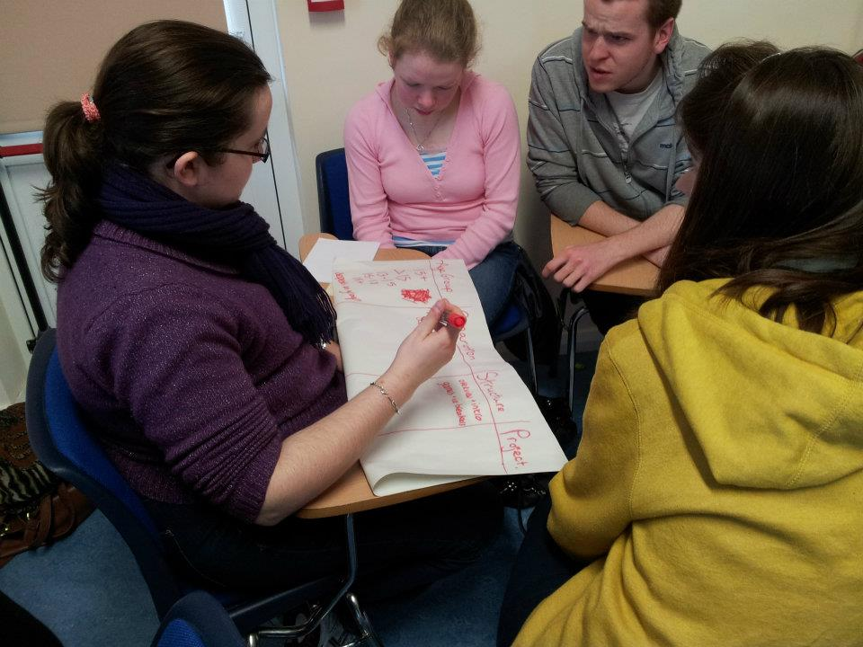
Discussing HIV with young people can be seen as a sensitive issue, however information can save lives, and the Irish Red Cross will adapt the programme in order to respect religious and cultural sensitivities. The course will be available in three versions, targeting separate age groups; under 15, 15–17 and over 18 years old, ensuring that the materials are appropriate to the different age groups.

“This programme was selected because not only does it use different kinds of methods to engage young people, but can be adapted to suit different target groups in the community. It’s clear that the Irish Red Cross thought about this in advance,” says Ruut-Maaria Mattsson, responsible for youth development at the IFRC’s Geneva office.

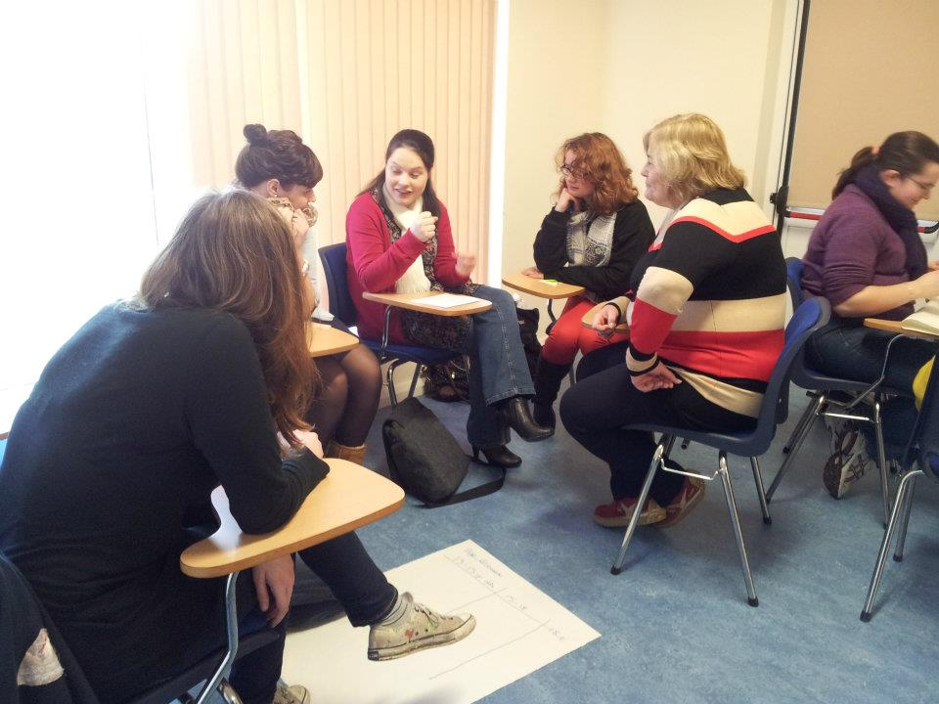 | Volunteer youth leaders of Red Cross will be trained as peer educators, further training other youth members and volunteers. In the first 12 months of the programme, the Irish Red Cross hopes to train at least half of their youth volunteers through this initiative.  No other HIV/AIDS awareness training In Ireland is reaching as large a group of people under the age of 25 through a single programme. This age group is targeted as they are at the highest risk of contracting HIV; almost 50 per cent of new infections are among young people.
For more information on the HIV Awareness Programme Training for Youth leaders, please contact Catriona Finn on cfinn@redcross.ie or 01 642 4600

