Migrants are people who leave or flee their home to go to a new place, usually abroad, to seek opportunities, international protection or safer and better lives. People on the move are entitled to the same human rights and protection as anyone else.
This year has seen a dramatic rise in the number of people attempting to make the dangerous crossing from North Africa to Europe, thousands of whom have died in the process. Due to globalisation, expectations for a better life in Europe, intensified conflicts in North Africa and Middle East and Europe having more restrictive policies on migration, a huge increase on unsafe sea crossing is being observed.
_________________________________________________________________________________
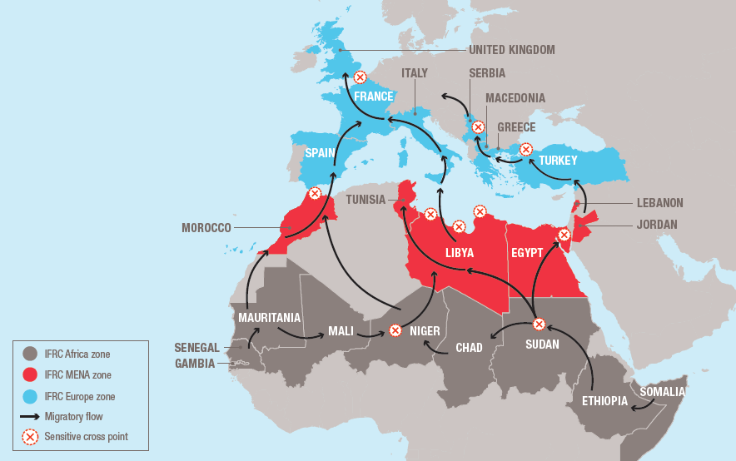
_________________________________________________________________________________
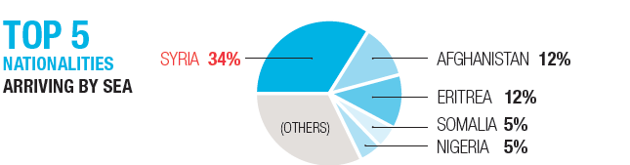
_________________________________________________________________________________
The issue is not only confined to the Mediterranean. Similar tragedies have unfolded in Southeast Asia and the Middle East. It is also not an issue confined to dangerous journeys people make by sea, many die or are at risk as they make their way over land and across borders.
- The Red Cross Red Crescent is focused on meeting the humanitarian needs of migrants, protecting people on the move, preventing loss of life and treating people with dignity, and calls for a humanitarian approach to tackling the vulnerabilities of migrants, rather than focusing on their legal status.
- When they land, many migrants are in need of first aid, relief items such as clothes, food psychosocial support, transportation, reconnecting with loved ones who they have been separated from, access to health services, including the urgent hospitalisation of those with serious medical conditions.
- More than 98,000 migrants have arrived on Italian shores so far this year. Italian RC is currently operating in early port in Italy, working with the Ministry of Health to provide health assistance, reception facilities and relief for those arriving by boat. In Sicily alone, the main landing point, Italian RC has a network of more than 2,300 volunteers working to help migrants rescued by the Italian Coast Guard.
- This weekend saw thousands of migrants have resumed their journey north through Macedonia and into Serbia after Macedonia reopened its border with Greece. Many migrants had been stuck at the border for days after Macedonia declared a state of emergency and sealed the crossing.
- The Hellenic Red Cross is responding to the immediate needs of 10,000 people arriving to the islands of Rhodes, Kos, Chios, Lesbos, Samos and Crete. Access to health services is a serious challenge at many ports of arrival – pregnant women and people with medical conditions may experience difficulties in accessing adequate treatment quickly.
- The current and planned activities in the Red Cross Red Crescent in affected countries is to respond to immediate needs. As the emergency evolves or continues to be prolonged, we will scale up our operations.

ENDS

