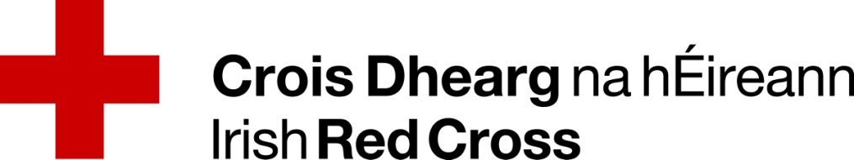

IRC Health & Social Care Good Practice/Event Submission
The purpose of this submission is to help create a database of initiatives and events which members can use in their own Branches and Areas to improve our Health and Social services to our communities. By submitting this record you are helping fellow members in the way they provide services.
SUBMITTED BY:
Name:
Membership Number:
Branch | Area: | Region:

GOOD PRACTICE INITATVIVE AREA
Please select from the below which area your initiative is closest linked to:
Saving Lives, Protecting livelihoods & strengthen recovery from crises
Enable Health & Safe Living
Promote Social Inclusion & a culture of non violence & peace

GOOD PRACTICE NAME/BRIEF DESCRIPTOR
Provide the title and/or a short description of the activity/initiative:

ACTIVITY/INITATIVE DESCRIPTION:

RESOURCES REQUIRED
Below list and or describe the materials required to complete the activity or initiative including any costs:

LEARNING POINTS
After reviewing your event have you identified any learning points if you are to run the activity again?

Additional Information/ comments:

Thank you for taking the time to complete this document. Your contribution is very much valued.
Please return this document to healthandsocialcare@redcross.ie

